
Fee Schedule Correction
RFP No. 26-01
Master Custody Services
March 6, 2026

The original Fee Schedule provided with the RFP contained a calculation error.
Please see the attached revised Fee Schedule. Enter the monthly charge for the Unit Price to calculate Annual Fees
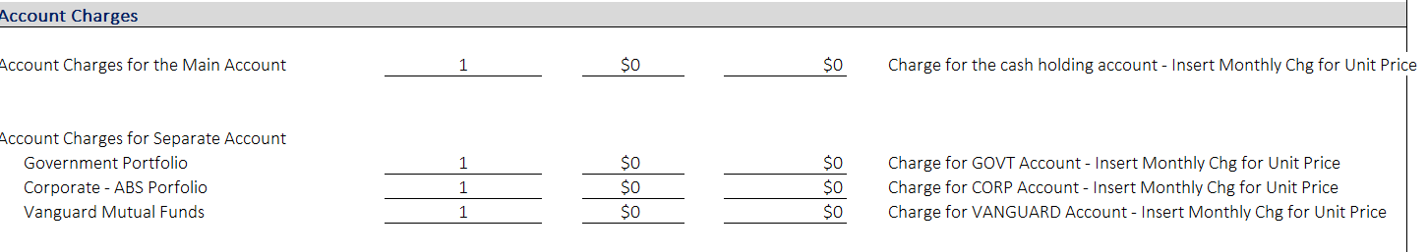

Duly Authorize Officer, please sign and return this statement along with submitted proposal.

Signed this __________ day of ______________________, 2026.

By:
Name of Official:
Title of Officer:
Name & Address of Investment Manager:

